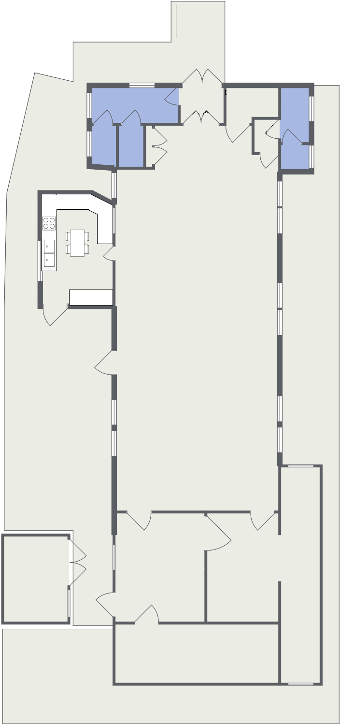

**Main Hall**

**Meeting**

**Room**

**Storage**

**Storage**

**Storage**

**Ladies Toilets**

**Gents**

**Toilets**

**Disabled**

**Toilets**

**Kitchen**